MACH4METAL

metalworking machinery
Transito 21
6909 DA BABBERICH Netherlands
Tel. +31 (0)316-247123
Fax: +31 (0)316-247956
info@mach4metal.com
www.mach4metal.com

Bank No : 66.52.13.883
IBAN : NL33 INGB 0665 2138 83
BIC : INGBNL2A

MG 4 roll plate bender 2000 x 10
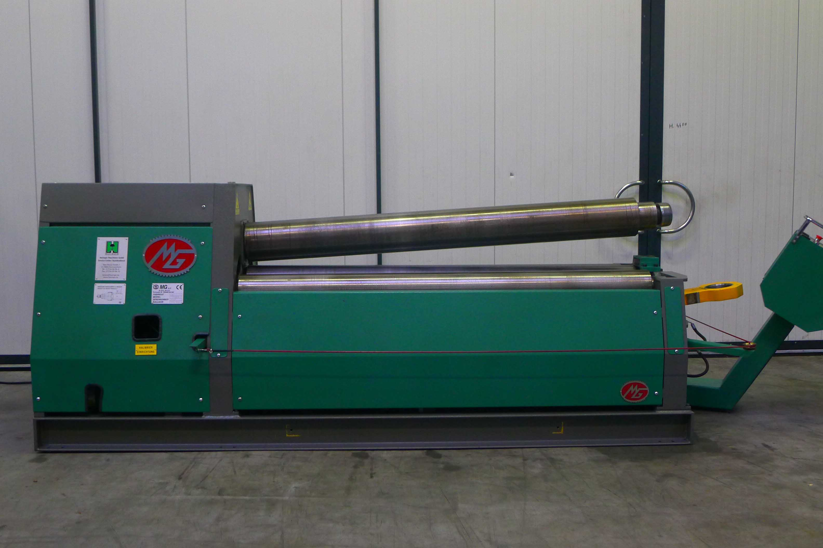

- Make : MG Italia
- Typ : MH 2010 B
- Serial : 08313
- Age : 2009

- Bending length : 2.050 mm
- Bending thickness : 10 mm
- Pre bending : 6 mm

- Top roll Ø : 210
- Lower roll Ø : 190
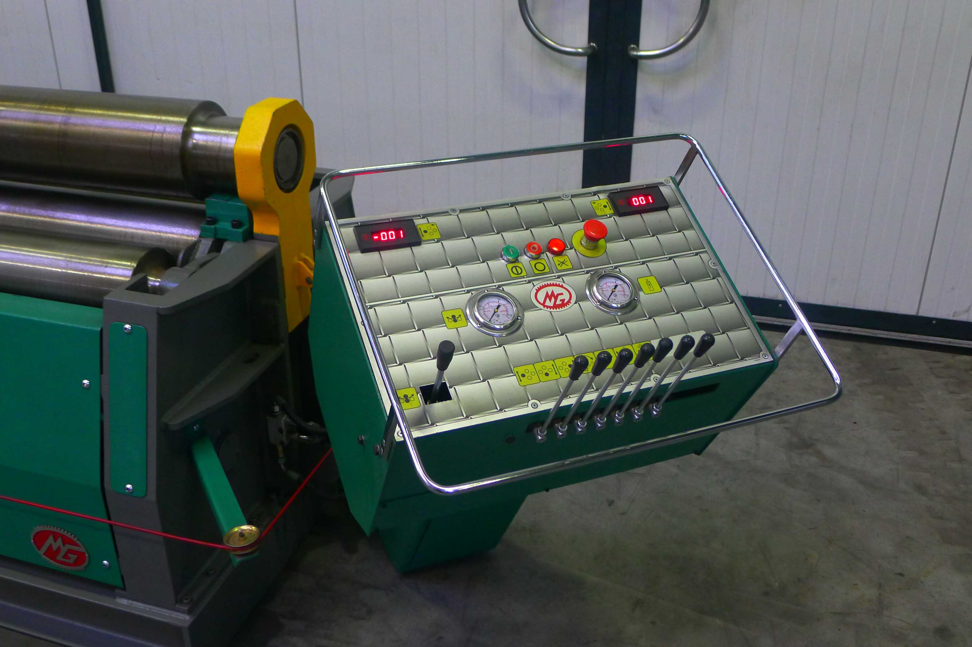
- Side roll Ø : 170

- 2 rolls driven upper & lower
- Working speed

- Central lubrication
- Digital readout side rolls
- Hardened rolls 53 – 55 HRC

- Conical bending attachment
- CE Safety guides
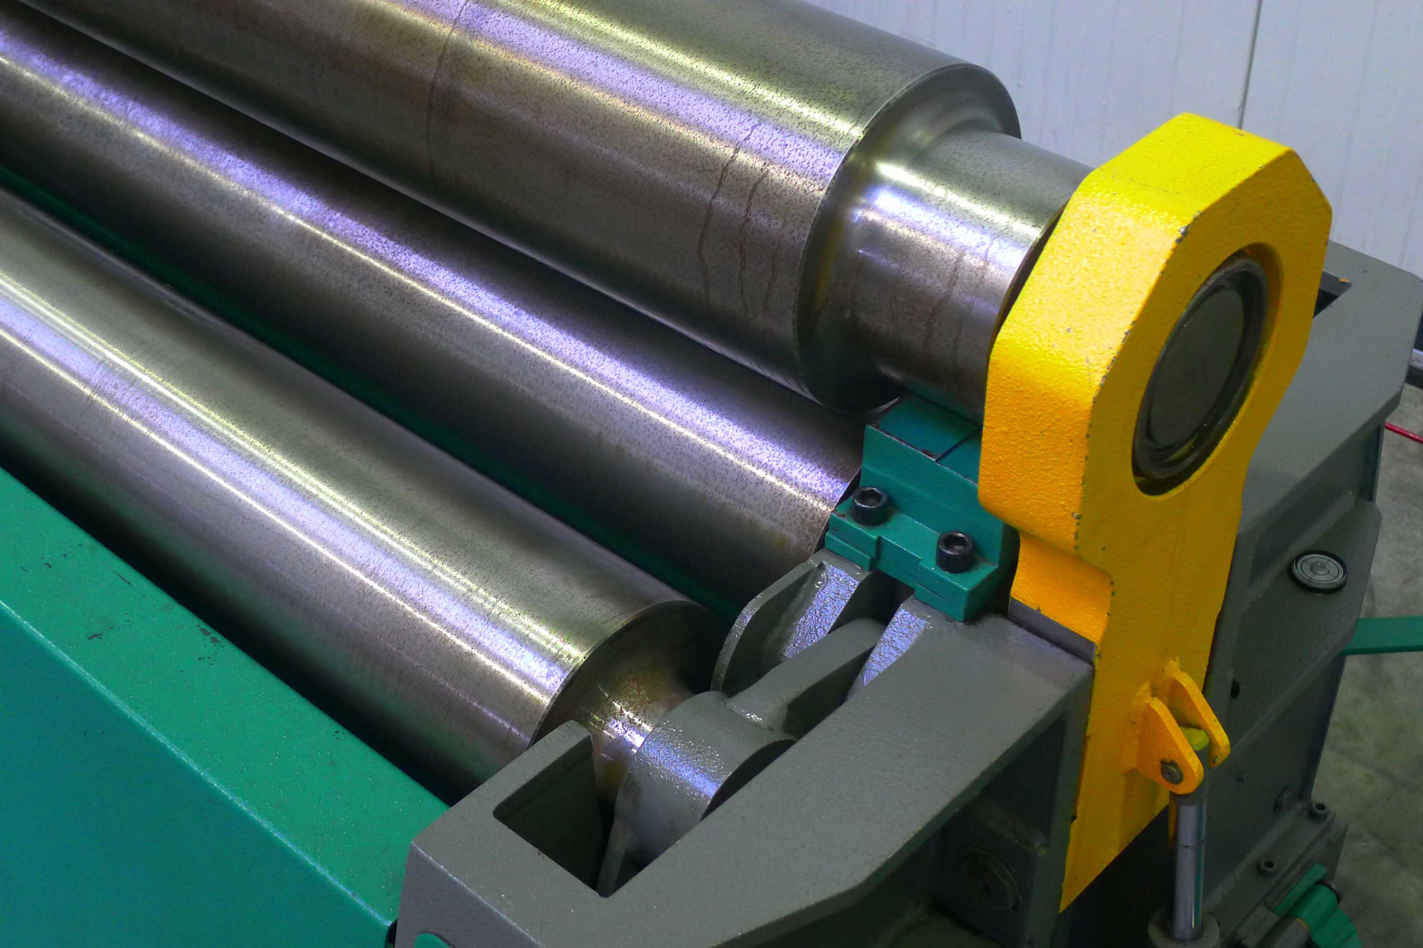

- Dimensions
- Length : 3000
- Width : 1600
- Height : 1800
- Weight : 5000

Please Note: The above information has been obtained to the best of our ability and belief from, and from the manufacturers where possible. It is given in good faith, but its accuracy can not be guaranteed. Accordingly, it will not form a representation or constitute contractual terms. We advise you to check any vital details!

